KETTLESHULME ST JAMES CE (VA) PRIMARY SCHOOL

Admissions Policy 2025-2026

Adapted in light of new admission code 2021
Updated: Spring 2024
Review Date: Spring 25

Kettleshulme St James CE (VA) Primary School

ADMISSION POLICY 2025/2026

“A loving branch from which to soar.”

Making an Application
All requests for admission are managed in consultation with the Governors of Kettleshulme St James CE Primary School. The timetable for admission, along with the online application, can be found here for parents with a Cheshire East postcode:

https://www.cheshireeast.gov.uk/schools/admissions/admissions.aspx
0300 123 5012 - option 1
or here for parents with a Derbyshire postcode:
https://www.derbyshire.gov.uk/education/schools/school-places/apply-for-a-school-place.aspx
01629 533190

*Please note – the deadline for new Reception starters is 15th January.
**Please note – all in-year applications (i.e. not a September start) should be made via Cheshire East.
***Parents applying from Combs Infant School (Derbyshire) have a deadline of 15th March for applications and should apply via Derbyshire admissions.

It is not normally possible to change the order of parental preferences for schools after the closing date.
Letters informing parents of whether or not their child has been allocated a place will be sent out by the Local Authority on 16th April or the next working day. Parents of children not admitted will be informed of the reason, offered an alternative place by the Authority and be made aware of the right to appeal.

Admission Procedures

The planned admission number to the Reception class is 9. This arrangement follows consultation between the Governing Body, the Diocesan Board of Education, Local Authorities and other Admissions Authorities in the area. No restrictions will be placed on admissions unless the number of children for whom admission is sought exceeds this number. By law, no infant class may contain more than thirty children.
Places are allocated according to the criteria, with each application treated equally regardless of where the school sits within the preferences expressed.
All children with an Education Health and Care Plan in which the school is named will be admitted.

In the event that there are more applicants than places, the Governing Body will allocate these places using the following criteria which are listed in order of priority:

- Looked After Children and previously Looked After Children. A 'looked after child' or a child who was previously 'looked after', but immediately after being looked after became subject to an adoption, child arrangements, or Special Guardianship Order including those who appear to the Admission Authority to have been in state care overseas and ceased to be in state care as a result of being adopted. A 'looked after' child is a child who is (a) in the care of a local authority, or (b) being provided with accommodation by a local authority in the exercise of their social services functions (see the definition in Section 22(1) of the Children Act 1989). A child is regarded as having been in state care outside of England if they were in the care of or were accommodated by a public authority, a religious organisation or any other provider of care whose sole main purpose is to benefit society.

- Children with special medical or social circumstances affecting the child where these needs can only be met at this school. Professional supporting evidence from e.g . a doctor, psychologist, social worker, is required which sets out the particular reasons why the school in question is the most suitable school and the difficulties which would be caused if the child had to attend another school.

- Children living in the valley of Kettleshulme (see attached map, Appendix A)

- Children with a sibling attending the school at the time of application. Sibling is defined in these arrangements as children who live as brother or sister in the same house, including natural brothers or sisters, adopted siblings, stepbrothers or sisters and foster brothers and sisters.

- Children whose parent/s have a proven commitment to worship at a Christian church. A proven commitment is attendance at worship, at least four times in six months prior to the closing date for school applications (15th January). A Christian church is any church which is affiliated to Churches Together in Britain and Ireland. A completed Supplementary Information Form (which can be found on our school website) is required and should be submitted to the school by 15th January. See Appendix B for a copy.

- Other children by distance from the school. Priority for admission will be given to children who live nearest to the school measured using the National Land and Property Gazetteer (NLPG) which measures straight line distances from the school’s coordinate point to the place of residence’s coordinate point.

Random allocation will be used as a tie-break in the above final criterion to decide who has highest priority for admission if the distance between two children’s homes and the school is the same. This process will be independently verified. If a tie-break is required in earlier criteria to decide between two children as to who has priority for admission, distance from the school as measured above will be used.

Waiting list

When there are more applications than places, the Admissions criteria will be used. Children who are not admitted will have their name placed on a waiting list by written request. The names on this waiting list will be in the order resulting from the application of the Admissions criteria. Since the date of application cannot be a criterion for the order of names on the waiting list, late applicants for the school will be placed in order according to how they meet the criteria. It is therefore possible that a child who moves into the area later will have a higher priority than one who has been on the waiting list for some time. If a place becomes available within the Admission number, the child whose name is at the top of the list will be offered a place. This is not dependent on whether an appeal has been submitted.

This waiting list will operate until the 31st December of the year of admission.

Late applications for admission

Where the Local Authority accepts that there are extenuating circumstances for an application being received after the last date for applications and it is before the list of pupils to be admitted has been established, then such a late application will be considered alongside all the others.
Otherwise, applications which are received after the last date will be considered after all the others and where applicable, placed on the waiting list in order according to the criteria.

Address of pupil

The address used on the school’s Admission Form must be the current one at the time of application. If the address changes subsequently, the parents should notify the school. Where the parents live at different addresses, the one used will normally be the one where the child wakes up for the majority of Monday to Friday mornings. Parents may be asked to show evidence of the claim made for the address, e.g. utility bills of various sorts showing the child’s address as the one claimed. For children of UK Service personnel and other Crown Servants returning to the area, proof of the posting is all that is required.

In-Year Admissions

It sometimes happens that a child needs to change school other than at the ‘normal’ time; such admissions are known as non-routine or in-year admissions. All in-year applications should be made via Cheshire East.

Appeals

Where the Governors are unable to offer a place because the school is over-subscribed, parents have the right to appeal to an independent Admission Appeals Panel. Parents should notify the Clerk to the Governors at the school within 20 school days of receiving the letter refusing a place. Parents will have the opportunity to submit their case to the Panel in writing and also to attend in order to present their case. Parents will normally receive 14 days notice of the place and time of the hearing.

Please note that this right of appeal against the Governors’ decision does not prevent parents from making an appeal in respect of any other school.

Fraudulent applications

Where the Governing Body discovers that a child has been awarded a place as the result of an intentionally misleading application from a parent (for example a false claim to reside in the catchment area or of involvement with a place of worship) which effectively denies a place to a child with a stronger claim, then the Governing Body is required to withdraw the offer of the place. The application will be considered afresh and a right of appeal offered if a place is refused.

Deferred Admission

Children are eligible for a Reception place from the beginning of the school year in which they become 5 years old. However, they do not become of compulsory school age until the start of the term after their fifth birthday. After a place has been allocated and accepted, parents may defer the school place until later in the school year and, if they choose to do this, the place will be held for the child. However, they cannot, defer entry beyond the beginning of the term after the child’s fifth birthday nor beyond the Summer Term.

Children educated outside of their normal age group

Parents who wish to delay entry until the following year due to specific circumstances, such as ill health or summer born children (those between 1st April and 31st August), must speak to the school and Local Authority as soon as possible as this would involve either an in-year application for Year 1 or a new application for Reception in the following year. The decision as to which Year Group the child will enter will be made taking into account information from the parents and Headteacher and should be made in the best interests of the child.
Parents should be aware that agreement by the school to allow a child to enter Reception in the following year does not guarantee a place in the class. Parents must apply to the school in the normal co-ordinated round and the application will be considered in the normal manner following the oversubscription criteria. Parents may also choose to apply in-year for admittance to Year 1 and the child’s normal age group.

APPENDIX A
Map outlining Kettleshulme valley boundary line
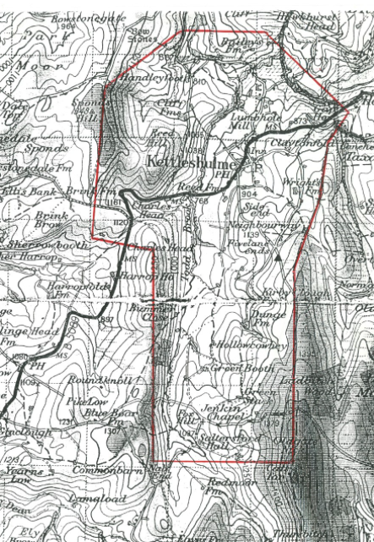
APPENDIX B

Supplementary Information Form for Kettleshulme St James CE Primary School

Name of child:
Surname |  |  | First names
Date of birth
Name of parent/guardian
Address

Place of worship parent/ guardian regularly attends:
Name and location of place of worship
I confirm that I comply with Item 5* in the Admission Procedure Priority Order.  *Item 5 - Children whose parent/s have a proven commitment to worship at a Christian church. A proven commitment is attendance at worship, at least four times in six months prior to the closing date for school applications (15th January). Christian church being any church which is affiliated to Churches Together in Britain and Ireland.  Please circle |  | YES NO
Name of vicar or church minister/officer
Telephone

Church Vicar or Minister Confirmation of worship attendance

Name of Vicar or Minister………………………..…………. Signature…………………………………...

