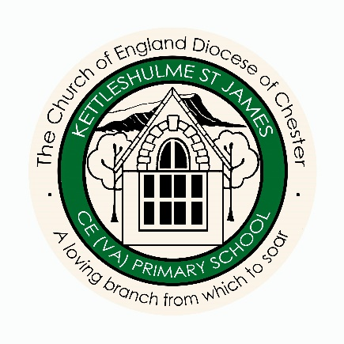
Governance Statement 2022/23

Welcome
This is the third governance statement I have prepared since joining the governing body at Kettleshulme St James and I am struck, as in prior years, by how quickly the School year seems to pass by. I have concluded that there is truth in the adage that “time flies when you’re having fun”.
As a governor in a relatively small school, you have the chance to know the School well and see its vision and values in action. I always feel heartened when I visit and see the School’s staff, working so well as a team to create a healthy, safe and happy environment from which to deliver effective learning.
The governing body recognises the factors that affect workplace wellbeing and the impact this can have on creating a stable and welcoming setting able to unlock a child’s potential and ability to soar. This led us to explicitly reflect this in our Strategic Vision Mission Statement last year and, in a nutshell, our objectives are:
Governor’s Strategic Vision – October 2023
- To see the school’s vision and values lived and breathed in all aspects of school life

- To create a sustainable school with a good reputation, valued by the “Kettleshulme Family”

- To have meaningful engagement with key stakeholders

- To create a financially secure school, and

- To protect and enhance the wellbeing of our staff

The national picture
Although rooted in our local community we acknowledge that the School is not immune from external influences and last year saw challenging and persistent national trends in the education sector. Media coverage highlighted pressure on schools and their funding, strike action, the rise in safeguarding concerns and falling pupil attendance, amongst other things. At Kettleshulme St James we are mindful of the wider outlook and utilise both local and national benchmarking where appropriate when monitoring what happens in School. We do however remain focused on meeting the needs of our School and delivery of its vision and values.
Closer to home
The School’s website provides helpful information about school life. It showcases the way the School supports learning, social connection and much more. Good governance is at the heart of this, with trusting and respectful relationships with the School’s leadership and wider team. We continue to support and challenge to ensure the School is well prepared, well led and well equipped to deal with whatever the future brings.
It was pleasing to receive an outcome of “Good Assurance” from Cheshire East Council’s Schools Finance Team to our 2022/23 submission for the School’s Financial Value Standard. The feedback noted “Your school has remained good which is positive. Thank you for maintaining this high standard.”
As the School is currently operating without a financial deficit, it has been able to allocate spending to retain the number of teaching staff whilst adding to its team of support staff. Curriculum resources have been reviewed resulting in developments to assist the staff’s continued focus on delivery of a broad, effective and balanced curriculum, improving attainment and on-going assessment and monitoring.
From this stable base there is so much more that the School and its leadership wish to achieve. Development will continue and governors will continue to support, challenge and utilise experience and enthusiasm for the benefit of the Kettleshulme Family; of which we are part. We will also continue to maintain our sense of fun amidst the formality.
Before signing off I would like to share something that happened very early in the current academic year, (back in September). Having seen, via social media, updates on the redecoration in School over the summer holidays, one of our former pupils popped in at the end of a School day. They were keen to see for themselves how the newly renamed Forest, Meadow & Hillside classrooms looked. I happened to be in School for a meeting and as we walked around together, they were quick to let me know how impressed they were with the changes. After sharing with me how they were enjoying High School they then said, “Although I’m no longer a pupil at Kettleshulme, in my heart, this will always be my school.” We both went home feeling joyful that afternoon.
One last thought
Don’t forget, please spread the word, share details of the School website and FB page if you know of any families that are interested in enrolling children at Kettleshulme and encourage contact with Mrs Bellshaw, if they have any questions.

Annette Scott
On behalf of the Governing Body
January 2024

