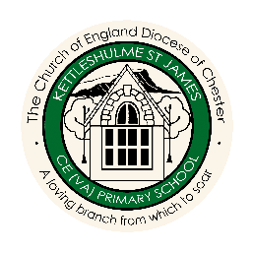
DT Overview
 |  | AUTUMN | SPRING | SUMMER
CYCLE A | FOREST  CLASS | WHERE WE LIVE! | FRIENDSHIP | WATER
 |  | Moving Picture | Fabric Faces | Dips and Dippers
 | MEADOW  CLASS | EGYPTIANS | HABITATS | STRONG
 |  | Great Bread Bake Off | Let’s Go Fly a Kite | Juggling Balls
 | HILLSIDE  CLASS | WORLD WAR 2 | SPACE | RIGHTS
 |  | Super Seasonal | Marbulous Structures | Global Food
CYCLE B | FOREST  CLASS | FAMILY AROUND US | GROWING | SAVING OUR PLANET
 |  | Fabric Bunting | Pirate Paddy’s Packed Lunch Problem | Sensational Salads
 | MEADOW CLASS | VIKINGS | MOUNTAINS AND RIVERS | SAVING OUR PLANET
 |  | Battery Operated Lights | Mechanical Posters | Edible Garden
 | HILLSIDE  CLASS | COASTS | NORTH AND SOUTH AMERICA | SAVING OUR PLANET
 |  | Programming Adventures | Automata Animals | Felt Phone Cases
DT Units of Work

