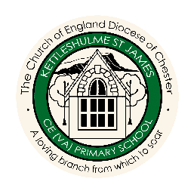
Art Overview
 |  | AUTUMN | SPRING | SUMMER
CYCLE A | FOREST  CLASS | WHERE WE LIVE! | FRIENDSHIP | WATER
 |  | Wonderful weather ( Lowry) | Portraits | Our Country
 |  | Our Local Area ( Miro)
 | MEADOW  CLASS | EGYPTIANS | HABITATS | STRONG
 |  | Ancient Egypt | European Art and Artists | Bodies
 | HILLSIDE  CLASS | WORLD WAR 2 | SPACE | RIGHTS
 |  | Fruit and Vegetables | North American Art | Plants and Flowers
CYCLE B | FOREST  CLASS | FAMILY AROUND US | GROWING | SAVING OUR PLANET
 |  | Colour Chaos | Landscapes and Cityscapes | Nature Sculptures
 | MEADOW  CLASS | VIKINGS | MOUNTAINS AND RIVERS | SAVING OUR PLANET
 |  | Autumn | British Art and Artists | Insects
 | HILLSIDE  CLASS | COASTS | NORTH AND SOUTH AMERICA | SAVING OUR PLANET
 |  | The Seaside | South American Art | Wildlife
Art Units of Work

