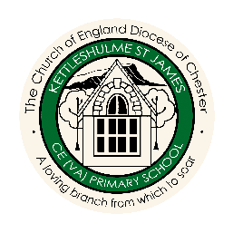
History and Geography Overview
 |  | AUTUMN | SPRING | SUMMER
CYCLE A | FOREST  CLASS | WHERE WE LIVE! | FRIENDSHIP | WATER
 |  | The United Kingdom | Australia | Continents and Oceans
 |  | Queen Victoria and  Queen Elizabeth II | Captain Cook discovering Australia | Mass Trespass
 | MEADOW  CLASS | EGYPTIANS | HABITATS | STRONG
 |  | Volcanoes and Earthquakes | Landscapes: weathering/Erosion and Deposition | International Trade: Food
 |  | Ancient Egypt | Tudors | Stone Age
 | HILLSIDE  CLASS | WORLD WAR 2 | SPACE | RIGHTS
 |  | Using Maps: features | Using Maps : 4 figure grid references | Ocean Currents
 |  | WW2 | Local History Study - Kettleshulme | Ancient Greece
CYCLE B | FOREST  CLASS | FAMILY AROUND US | GROWING | SAVING OUR PLANET
 |  | Mapping the World | Climate | Extreme Weather
 |  | Mary Seacole and Edith Covelle | The Great Fire of London | The Moon Landing
 | MEADOW CLASS | ANGLO SAXONS | MOUNTAINS AND RIVERS | SAVING OUR PLANET
 |  | Transportation | Europe (mountains, rivers and population) | Climate Change and  Maps of the world 1, 2 and 3
 |  | Anglo Saxons and Scots | Romans | Victorians
 | HILLSIDE  CLASS | COASTS | NORTH AND SOUTH AMERICA | SAVING OUR PLANET
 |  | Biomes and Climate Zones | North and South America | Climate Change
 |  | Anglo Saxons and Vikings | Aztecs | Iron Age
Curriculum Companion Units of Work

