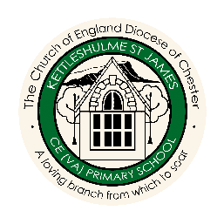
Science Overview
 |  | AUTUMN | SPRING | SUMMER
CYCLE A | FOREST  CLASS | WHERE WE LIVE! | FRIENDSHIP | WATER
 |  | Seasonal Changes (Yr1) | Everyday materials (Yr1) | Uses of everyday materials (Yr2)
 |  | Living things and their habitats (Yr2) | Everyday materials (Yr1) | Uses of everyday materials (Yr2)
 | MEADOW  CLASS | EGYPTIANS | HABITATS | STRONG
 |  | Rocks and Soils (Yr3) | Plants (Yr3) | Forces and Magnets (Yr3)
 |  | Sound (Yr4) | Plants (Yr3) | States of matter (Yr4)
 | HILLSIDE  CLASS | WORLD WAR 2 | SPACE | RIGHTS
 |  | Electricity (Yr6) | Earth and Space (Yr5) | Evolution and inheritance (Yr6)
 |  | Electricity (Yr6) | Light (Yr6) | Forces (Yr5)
CYCLE B | FOREST CLASS | FAMILY AROUND US | GROWING | SAVING OUR PLANET
 |  | Animals inc humans (Yr1) | Plants (Yr1) | Plants (Yr2)
 |  | Animals inc humans (Yr2) | Plants (Yr1) | Plants (Yr2)
 | MEADOW  CLASS | VIKINGS | MOUNTAINS AND RIVERS | SAVING OUR PLANET
 |  | Animals inc humans (Yr3) | Light (Yr3) | Living things and their habitats (Yr4)
 |  | Animals inc humans (Yr4) | Electricity (Yr4) | Living things and their habitats (Yr4)
 | HILLSIDE  CLASS | COASTS | NORTH AND SOUTH AMERICA | SAVING OUR PLANET
 |  | Animals inc humans (Yr5) | Properties and changes of materials (Yr5) | Living things and their habitats (Yr5)
 |  | Animals inc humans (Yr6) | Properties and changes of materials (Yr5) | Living things and their habitats (Yr6)
PZAZ Units of Work

