KETTLESHULME ST JAMES CE (VA) PRIMARY SCHOOL

FIRST AID, ILLNESS and
MEDICINES POLICY

Summer 2023
Review date - Summer 2024
Statutory Policy - FGB

The health and safety of all children, staff and visitors at Kettleshulme St James Primary School is of the highest importance to all staff. This policy explains the practices in place to address the health needs of the children, resulting from accidents or medical conditions. Whilst this policy is written with children in mind, much of the content applies to adults as well.

Through the proper care, support and first aid provision, most children should be able to access the whole curriculum. The detailed steps are addressed in this policy, giving consideration to both first aid and a range of conditions and illnesses.

First Aiders:

Please refer to the current list which is displayed in numerous locations around the school.

First Aid Equipment is kept:

- Forms kept in the blue ‘First Aid File’ in the School Office
- Grab bags in each classroom in labelled drawer
- Other files/medication locked in Headteacher’s filing cabinet (key on noticeboard)
- Sick bowls in staff toilet, blankets in the library
- Wet Floor sign in cleaning cupboard
- Head bump stickers kept in blue ‘First Aid File’
- Additional refill supplies are in the office cupboard
- Ice packs are kept in the large chest freezer in the caretaker’s cupboard
- Inhalers/medication are kept in the relevant classrooms with associated paperwork (it is the allocated Lead First Aider’s responsibility to check that all medication is in school and in date – to be checked half termly and recorded in First Aid File)
- All medical waste is disposed of in the female hygiene waste disposal in staff toilet
- ADDITIONAL FIRST AID FORMS ARE ON SCHOOL DOCS

Actions

Minor cuts/scraps etc - clean with non-alcohol based medi-wipes or clean water and if needed, plasters are available (it is important to note any children allergic to plasters). Vinyl gloves should be worn by staff, when dealing with blood.

Headbumps – wet paper towels only to be used for head injuries so that swelling remains apparent. First Aider to check for symptoms of dizziness, confusion, memory loss, blurry vision, sleepiness, headache, slurred speech, restlessness and sickness. First Aider to check on patient approximately 30mins after the incident and recheck for any of the above symptoms. If any symptoms are present then immediate medical attention to be sought.

Potential broken bone/sprain – get a second First Aider, phone parents, make a judgement about whether or not the patient can be moved, be mindful of patient going into shock, decide ambulance or parent required to take to hospital - do not leave patient alone.

Vomiting – if a child is vomiting they should be taken to the toilet until a sick bowl (located in the staffroom cupboard) is brought to them. The child should not be left alone at any time. After attending to the child’s needs, ensure any vomit on the floor is covered by absorbent powder available (located in the staffroom). Wet floor signs may be used as a warning (located in cleaning cupboard). It should be cleaned up as soon as possible. Soiled clothing should be removed and placed in a plastic bag. The child’s PE kit should be used instead. Parents/carers should be contacted immediately and asked to collect their child. Children may not return to school until 48 hours after vomiting.

Recording:

Minor cuts/scraps etc – to be recorded in Blue Folder kept in office shelf (next to the shredder)
See Appendix 1

Headbumps – sticker given by First Aider (located in School Office) / School Spider notification to be sent home / Class Teacher informed / Head Bump form completed and put in Blue Folder/copy of headbump incident form sent home with child. ALL HEADBUMPS MUST BE RECORDED, EVEN IF THEY ARE ONLY MINOR. Patient must be sent home if any of the previously listed symptoms are present.
See Appendix 2

Potential broken bone/sprain – recorded in Blue Folder, if patient goes to hospital, then follow up phonecall will be made later that day/next day to secure information needed for PRIME (Mrs Blood to complete PRIME).

First Aiders responsible:

Lesson time: class teacher if able/trained, otherwise admin staff / Headteacher.

At playtime: any minor injuries should be dealt with on the playground if a First Aider is on playground duty. The First Aid ‘grab bag’, located in the office, should be used for this purpose. If further treatment is required then another member of staff could be called out, using the walkie talkie, to relieve the First Aider of her playground duties. If no First Aiders are on duty then any First Aider should be called. Class teachers should be informed of any injury/suspected illness.

At lunchtime: Midday Assistant to call for help using walkie talkie. Nearest First Aider to attend. Class teachers should be informed of any injury/suspected illness.

If it is thought that a child needs to be sent home then only the Headteacher or a member of the Senior Leadership Team (“SLT”) can authorise this. The First Aider who has dealt with the incident should make the call FROM THE OFFICE so that the office staff are kept fully informed.

School Trips: The First Aider attending the trip, or connected with that year group should be requested 48 hours before hand to prepare first aid packs, sick bowl, paper towels and vital medication for the trip. A class medical and home phone number list should be taken. The first aid pack should be carried by the teacher or First Aider for use in minor incidents. Any prescribed medication for children or staff attending the trip, e.g. inhalers/antihistamine/adrenalin needed for emergencies, must be carried by the First Aider. If a more serious incident occurs away from school, first aid help should be sought from the site being visited, if possible. Otherwise, an ambulance should be called and the school informed. If a child requires travel sickness tablets they can only be administered by staff if the relevant paperwork has been completed and medication is in the original packaging. If not, then staff will have to refuse to administer them.

Sporting and other off-site educational events: Staff should ensure they are aware of any medical needs prior to the event and take with them basic first aid bag, details of any medical needs, class contact list and any emergency medication.

Before and After School Provision: Staff should be aware of any children who may require emergency medication and where it is kept. Any clubs run by outside agencies should have their own qualified First Aider.

Serious Medical Incidents

Incidents dealt with in school: A First Aider should be sent for immediately to deal with the incident. If it is serious, they should call for a second First Aider via the walkie talkie. The child must not be left unattended at any time. If referral to hospital is necessary the First Aider will accompany the child to the hospital, along with another member of staff. The office will be informed and will be asked to contact parents/carers to meet the staff and child at hospital as soon as possible. A detailed incident sheet should be kept by the First Aider so that the correct information can be given to the hospital and parent/carer when they arrive.

Incidents requiring emergency attention: The decision to call an ambulance will be made by a First Aider. They will inform the school office to do so via a walkie talkie. A member of the SLT must be informed immediately. The office will call the ambulance, preferably within speaking distance of the First Aider to ensure correct information is given about the casualty, age and injury. The office will contact parents/carers at this point by phone.

A member of staff will wait outside for the ambulance to arrive.

Any emergency medication should be administered and the First Aider should remain with the casualty at all times. The First Aider who dealt with the incident to accompany the casualty to hospital until the parents/carers arrive.

Following any referral or attendance at hospital, Prime Safety must be informed. Mrs Blood or Mrs Bellshaw must be given full details of the lighting, floor surface, incident, witnesses and any other relevant information as soon after the incident as possible, so that they can report it. Photographic evidence of the site is also desirable.

Children requiring short term medicine in school

Wherever possible parents are to administer medicine at home, eg antibiotics, however when this is not possible only a First Aider is to administer any medication in school. In order for medication to be administered in school, by a trained First Aider the following must be in place:
- Medication must be prescribed, with the child’s full name on it and in its original packaging
- Parent/carer must have completed the school’s ‘Administration of Medicines Consent Form’ See Appendix 3
It is best for administration of medicine to occur at either break or lunchtime wherever possible.
When a dose has been administered it must be recorded on the above- mentioned form to ensure extra doses are not given. When the prescribed course is finished, the form is passed to the school office to go in the child’s file and any unused medicine is to be given to parents. If it occurs that the child is requiring medicine to be administered repeatedly over time then a meeting will be held with parents to discuss the introduction of a Health Care Plan.

Children requiring long term medicine/medication in school

Some children, whilst fit to attend school, may, for prolonged periods of time or permanently, need to take medicine in school hours (for example those with severe allergies, diabetics, epileptics, asthmatics, etc). In this case the following additional guidelines apply:

- Parents must make a written request for medicines to be administered
- The First Aider shall ensure that a named person is responsible for medicines, together with a nominated deputy. The day-to-day mechanics of medicine will usually be delegated to the First Aider linked with the child’s class (this may be a key worker employed to work specifically with the child)
- The medicine will be provided by the parents
- Parents must supply in-date and named prescribed medicines
- A Health Care Plan will be produced together with the parents
- The medicine must be provided in its original container clearly labelled with:
child’s full name, name of medicine, dose (inhalers to have a clear label stuck directly onto the inhaler)
- Parents must notify school in writing of any changes in medicine/dosage and are responsible for checking medicine is in date
- A copy of the Health Care Plan will be kept in the Blue file
- Medicines no longer required should be returned to the parents/carers for disposal and any related forms filed with the child’s record. If medicine is not collected it should be taken to the local chemist for correct disposal

Health Care Plans (See Appendix 4) should include the following:
- Details of the child’s medical condition
- Date of birth and address
- Special requirements i.e. dietary needs, pre-activity precautions, etc.
- Any side effects of the medicines
- What constitutes an emergency
- Who to contact in an emergency
- Doctor’s name and contact details
- The role staff can play

Asthma varies from child to child and can vary from a persistent cough, wheeze and tightness of the chest. Children are usually aware that they are having an asthma attack and should be encouraged to say when they need their inhaler. They usually know how to use their inhaler correctly with supervision and respond well and quickly to treatment. Inhalers are labelled and kept in the child’s classroom in the allocated spot for First Aid, with a backup inhaler for general use kept in the Headteacher’s office. Children know where they are kept and that they can access them when they need to. When leaving the school ground (for a walk/the daily run etc) inhalers must be taken too. First Aiders keep the inhalers at all times.

With any medicine, should a child refuse to take it, staff should not force them to do so, but should note this on the records and inform parents of the refusal on the same day.

Pain relief

Generally, if pain relief is required, then the child is not well enough to be in school. Pain relievers should not normally be administered by school staff unless these have been prescribed or for specific needs, such as following surgery or a bone injury.

Sudden Onset Conditions

There may sometimes be extreme circumstances when a child suddenly needs pain relief in school, but they do not have any prescribed. In this situation if the parent is unable to collect their child within 2 hours of the complaint arising, then we will revert to our ‘Sudden Onset Conditions Form’ (Appendix 5). This will be sent out to all parents when they join our school and will remain active during their time at Kettleshulme. Here, parents have the chance to opt in or out of school administering Calpol/Piriton/After Bite in extreme circumstances when their child is suffering extreme pain/discomfort and parents are unable to collect immediately. Examples are: period pain, temperature, wasp sting or toothache. When we need to refer to the ‘Sudden Onset Conditions Form’ a First Aider will always ring the parents before any medication is administered

Illnesses

Kettleshulme St James CE (VA) Primary School adheres to the DfE and NHS guidelines with regard to illness exclusion times from school – please see the ‘Exclusions Table’ in Appendix 6 for this information. There will be no exceptions to these timescales.

In addition:

If head lice are suspected, staff should not inspect that child’s hair but instead a standard email will be sent to all parents with pupils in that class.

Lip salve may be brought into school by pupils - however this should not be shared between children.

Cough sweets may be brought into school but they should be kept with the class teacher.

Medical needs/allergies, along with photos, are listed in the office, staffroom and kitchen.

In cases where urgent treatment is required and the parent is not contactable, a teacher/First Aider would have authority to agree to ordinary medical treatment.

Parents who have specific beliefs, such as Jehovah’s Witnesses, which have implications for medical treatment, should make their views and wishes known to school so that the consequences of their beliefs can be discussed and, if possible, accommodated.

It is the responsibility of the Lead First Aider to ensure that all first aid resources are well stocked. Time will be allocated for them to complete a termly audit and a half termly check on grab bags etc.

Training

Staff should ensure that they are competent to deal with any treatment that they are taking responsibility for. If the school undertakes responsibility for the administration of special treatment, it is essential that adequate training is provided for the nominated persons. Any specific training required by staff on the administration of medication (e.g. epi-pen, diabetes, inhalers) is the responsibility of the school and would normally be arranged through a school nurse or in-house. Staff will not administer such medicines until they have been trained to do so.

The office will keep records of all staff trained to administer medicines and carry out other medical procedures. Training will be updated as appropriate.

Legal Liability

If a staff member undertakes the responsibility for administering medicines and a child were to have an adverse reaction, in the event of a claim by the parent/guardian then the Local Authority will indemnify the staff member concerned, subject to legal liability being established and if he/she has reasonably applied this policy.

Confidentiality

All medical information must be treated confidentially. The Headteacher will agree with the parent/carer as to who should have information about the medical needs of the child.

Communicating and Promoting the Policy

We will use staff meetings and training sessions to communicate the policy to staff; upload the policy onto the website; translate the policy where necessary and inform children where applicable.

Appendix 1 – Minor Injury Form
Date | Child’s full name | Injury and treatment | First Aider in attendance | Class teacher informed
04/07/19 | Joe Bloggs | Cut to knee – medi wipe and plaster | Mrs Hendry | Yes

Appendix 2 – Head Bump Form

HEADBUMP RECORD FORM

Date: | Full name: | Location of injury:  FRONT BACK |  | How did it happen? | Action Taken:  Could accident have been avoided?
Time: | Year Group: |  |  | Taken to Hospital?  Yes/No  Referred to Hospital? Yes/No | Does it require reporting to PRIME? Yes/No  PRIME number:
First Aider in attendance: |  | School Spider notification sent to parents by RB or AB:  YES / NO | This form p/c to send home along with guidance:  YES / NO
 |  | Class teacher informed:  YES / NO | Sticker given:  YES / NO

Additional Comments:

Your child has received a bump to their head today.

Your child was seen by a First Aider at school.

Please can you ensure that you observe your child closely for the next 24 hours and seek medical advice if necessary, especially if any of the below symptoms occur:

- Confusion or memory loss
- Nausea or vomiting
- Change to vision
- Excessive sleepiness
- Severe headache
- Slurred speech
- Restlessness or irritability
- Dizziness
Appendix 3 – Administration of Medicines Consent Form

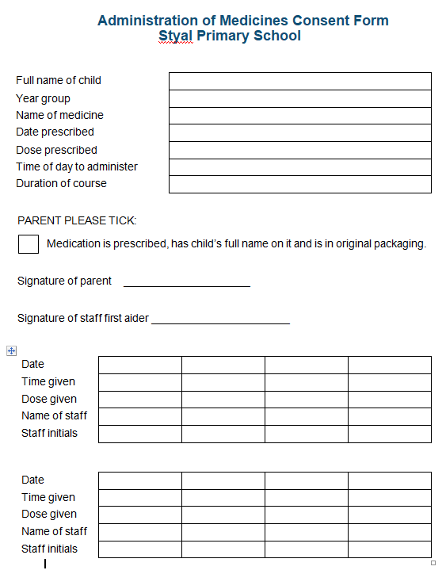

Appendix 4 – Individual Health Care Plan

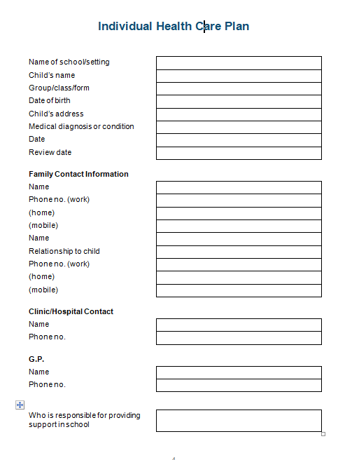

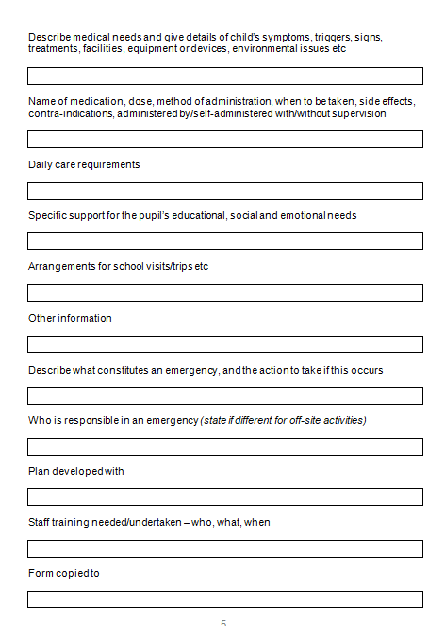
Appendix 5 – Sudden Onset Conditions Form

Administration of pain relief for sudden onset conditions

Children should not be sent to school if you know that they are unwell. However there are occasions when your child can develop into a state of unwell during the school day (for example as a result of the onset of a temperature, a wasp/bee sting, period pains, tooth-ache). The best option in this situation is always for you to collect your child and take them home, however we are aware that there are sometimes situations when this is not possible. For these unusual circumstances we ask that you complete the below opt in/out form, as we can only ever administer medication if we have written consent. This consent form will remain active throughout your child’s time at Kettleshulme

Please circle:

I give permission for my child to be given a 5ml dose of Calpol. YES / NO

I give permission for my child to be given a 5ml does of Piriton. YES / NO

I give permission for my child to have an application from an After Bite pen YES / NO

When we need to revert to referring to the above permissions form a member of staff will always ring you before any medication is administered.

Signed _____________________________________ Date __________________

Print name _________________________________

Appendix 6 – Exclusions Table

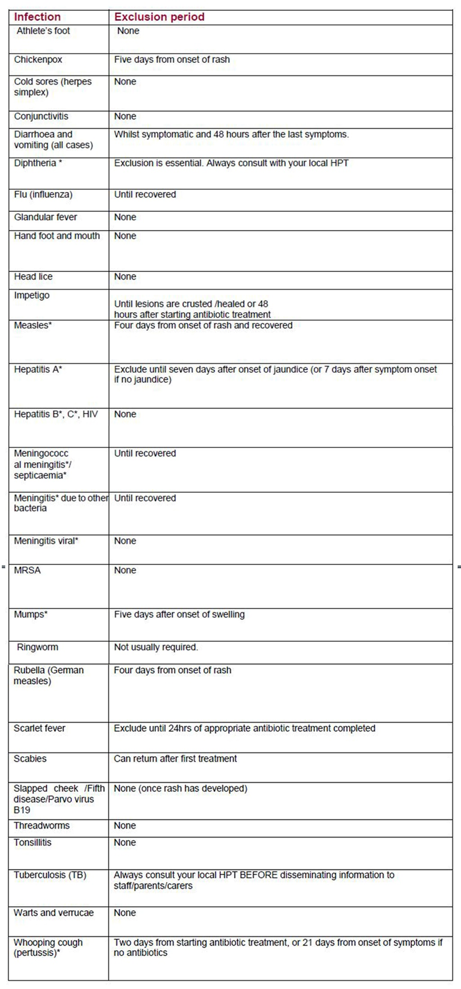

*denotes a notifiable disease. It is a statutory requirement that doctors report a notifiable disease to the proper officer of the local authority (usually a consultant in communicable disease control). Health Protection Agency (2010) Guidance on Infection Control in Schools and other Child Care Settings. HPA: London.

