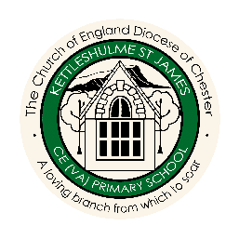
Famous People Overview
 |  | AUTUMN | SPRING | SUMMER
CYCLE A | FOREST  CLASS | WHERE WE LIVE! | FRIENDSHIP | WATER
 |  | Lowry  (Artist) | Mother Theresa  (Humanitarian) | Floella Benjamin  (Advocate for children)
 | MEADOW  CLASS | EGYPTIANS | HABITATS | STRONG
 |  | Evelyn Glennie  (Musician) | Leonardo Da Vinci  (Scientist and Artist) | Mary Seacole  (Inspirational nurse)
 | HILLSIDE  CLASS | WORLD WAR 2 | SPACE | RIGHTS AND DIVERSITY
 |  | Anne Frank  (Author and Survivor) | Galileo Galilei  (Astronomer) | Katherine Johnson  (Mathematician)
CYCLE B | FOREST  CLASS | FAMILY AROUND US | GROWING | SAVING OUR PLANET
 |  | Grace Darling  (Heroine) | Alys Fowler  (Horticulturist) | David Attenborough  (Naturalist)
 | MEADOW  CLASS | VIKINGS | MOUNTAINS AND RIVERS | SAVING OUR PLANET
 |  | Marie Curie  (Scientist) | Thomas Edison  (Scientist) | Greta Thunberg  (Activist)
 | HILLSIDE  CLASS | COASTS | NORTH AND SOUTH AMERICA | SAVING OUR PLANET
 |  | Alan Turing  (Computer Scientist) | Archimedes  (Scientist and Inventor) | John Muir  (Naturalist)

