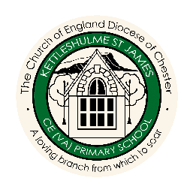
Enrichment Overview
 |  | AUTUMN | SPRING | SUMMER
CYCLE A | FOREST  CLASS | WHERE WE LIVE! | FRIENDSHIP | WATER
 |  | White Hall Adventure Half Day | White Hall Adventure Half Day | White Hall Adventure Half Day
 |  | Walk around Kettleshulme | School Link Visit | Visit to Blue Planet
 | MEADOW  CLASS | EGYPTIANS | HABITATS | STRONG
 |  | White Hall Adventure Half Day | White Hall Adventure Half Day | White Hall Adventure Half Day
 |  | Manchester Museum | Visit from Animal Magic | STEM scientist to visit
 | HILLSIDE  CLASS | WORLD WAR 2 | SPACE | RIGHTS AND DIVERSITY
 |  | White Hall Adventure Half Day | White Hall Adventure Half Day | White Hall Adventure Half Day
 |  | Visit to Stockport Air Raid Shelter on the train | Star Gazing at Teggs Nose | Visit from motivational speaker
 |  |  | Whole School Arts Based Experience – music, art or sport, funded by the PTFA | Whole School Visit to a Mosque, Synagogue or Buddhist Temple on a 3 year cycle
CYCLE B | FOREST  CLASS | FAMILY AROUND US | GROWING | SAVING OUR PLANET
 |  | White Hall Adventure Half Day | White Hall Adventure Half Day | White Hall Adventure Half Day
 |  | Visit from people who help us | Visit to the Garden Centre | Visit from Earth Cubs
 | MEADOW  CLASS | VIKINGS | MOUNTAINS AND RIVERS | SAVING OUR PLANET
 |  | White Hall Adventure Half Day | White Hall Adventure Half Day | White Hall Adventure Half Day
 |  | Viking to visit the school | Local field trip | Visit from Earth Cubs
 | HILLSIDE  CLASS | COASTS | NORTH AND SOUTH AMERICA | SAVING OUR PLANET
 |  | White Hall Adventure Half Day | White Hall Adventure Half Day | White Hall Adventure Half Day
 |  | Visit to the beach | Forest School Survival Day | Visit from Earth Cubs
 |  |  | Whole School Theatre Trip funded by PTFA | Pilgrims Day to Chester Cathedral

